1. What is Google Colab?

**Google Colab** is a **free** to use Jupyter notebook where you can execute Python code.

1. Accessing google Colab..

Type google colab



**Click on Google Colab link**

**Following screen will appear..**

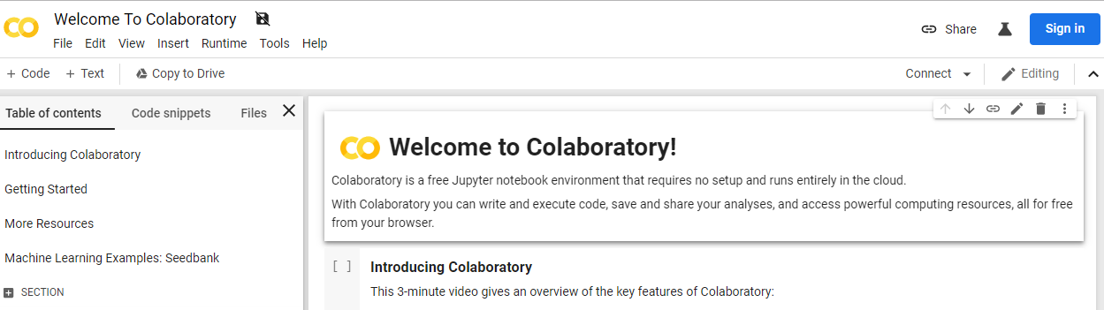

**Sign in through your gmail id..**

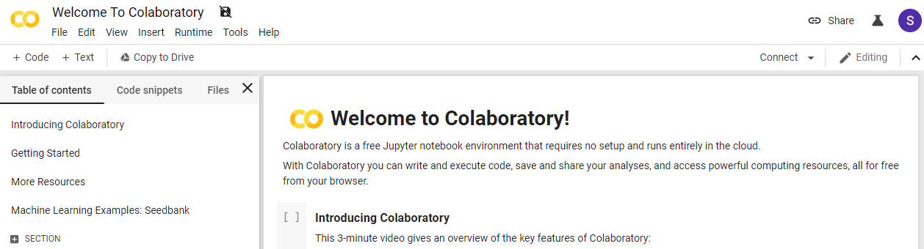

**Congratulations!! You are ready for Python for Data Science and Data Analysis and Visualization using python.**

**How to Upload CSV file?**

**Upload account.csv file**

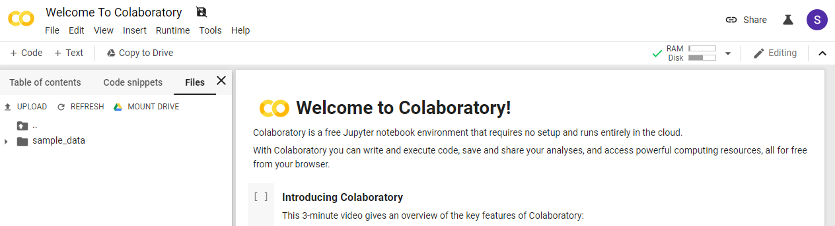

**Click on UPLOAD button…**

**Select file account.csv file from your Local drive…**

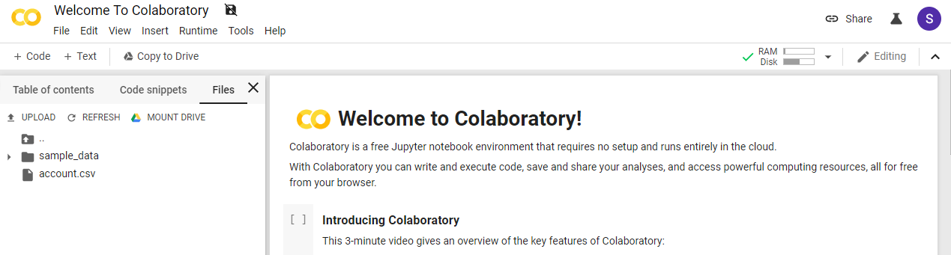

**You successfully uploaded your file…**